**Creating a Web Page with Map, Hotspot, Frames, and Links and Applying Embedded, External, and Inline CSS in a Web Page**

**EXP:1**

**AIM:**

To design a web page with an embedded map, hotspots, frames, and navigation links.

To demonstrate the use of embedded, external, and inline CSS styles.

# CODE:

**Hotspot.html**

<!DOCTYPE html>

<html>

<head>

<title>Hotspot</title>

<!-- Link to the external CSS file -->

<link rel="stylesheet" type="text/css" href="style.css">

<style>

h1 {

text-align: center;

color: #333;

margin-top: 20px;

}

</style>

</head>

<body>

<h1>Interactive Map of India</h1>

<img src="india map.webp" usemap="#indiamap" width="900" height="720" alt="Map of India">

<map name="indiamap">

<area shape="rect" coords="324,578,407,535" alt="Tamil Nadu" href="https://en.wikipedia.org/wiki/Tamil_Nadu">

<area shape="rect" coords="343,655,398,599" alt="Tamil Nadu" href="https://en.wikipedia.org/wiki/Tamil_Nadu">

<area shape="rect" coords="407,538,395,602" alt="Tamil Nadu" href="https://en.wikipedia.org/wiki/Tamil_Nadu">

<area shape="rect" coords="346,653,397,605" alt="Tamil Nadu" href="https://en.wikipedia.org/wiki/Tamil_Nadu">

<area shape="rect" coords="406,537,324,579" alt="Tamil Nadu" href="https://en.wikipedia.org/wiki/Tamil_Nadu">

</map>

</body>

</html>

# OUTPUT:

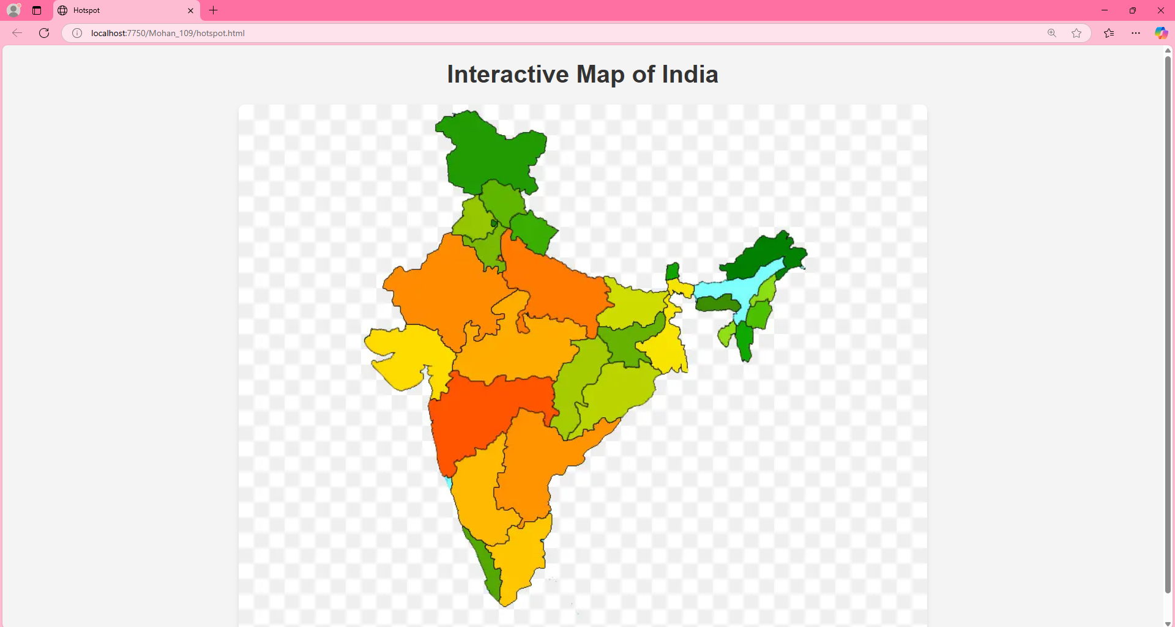

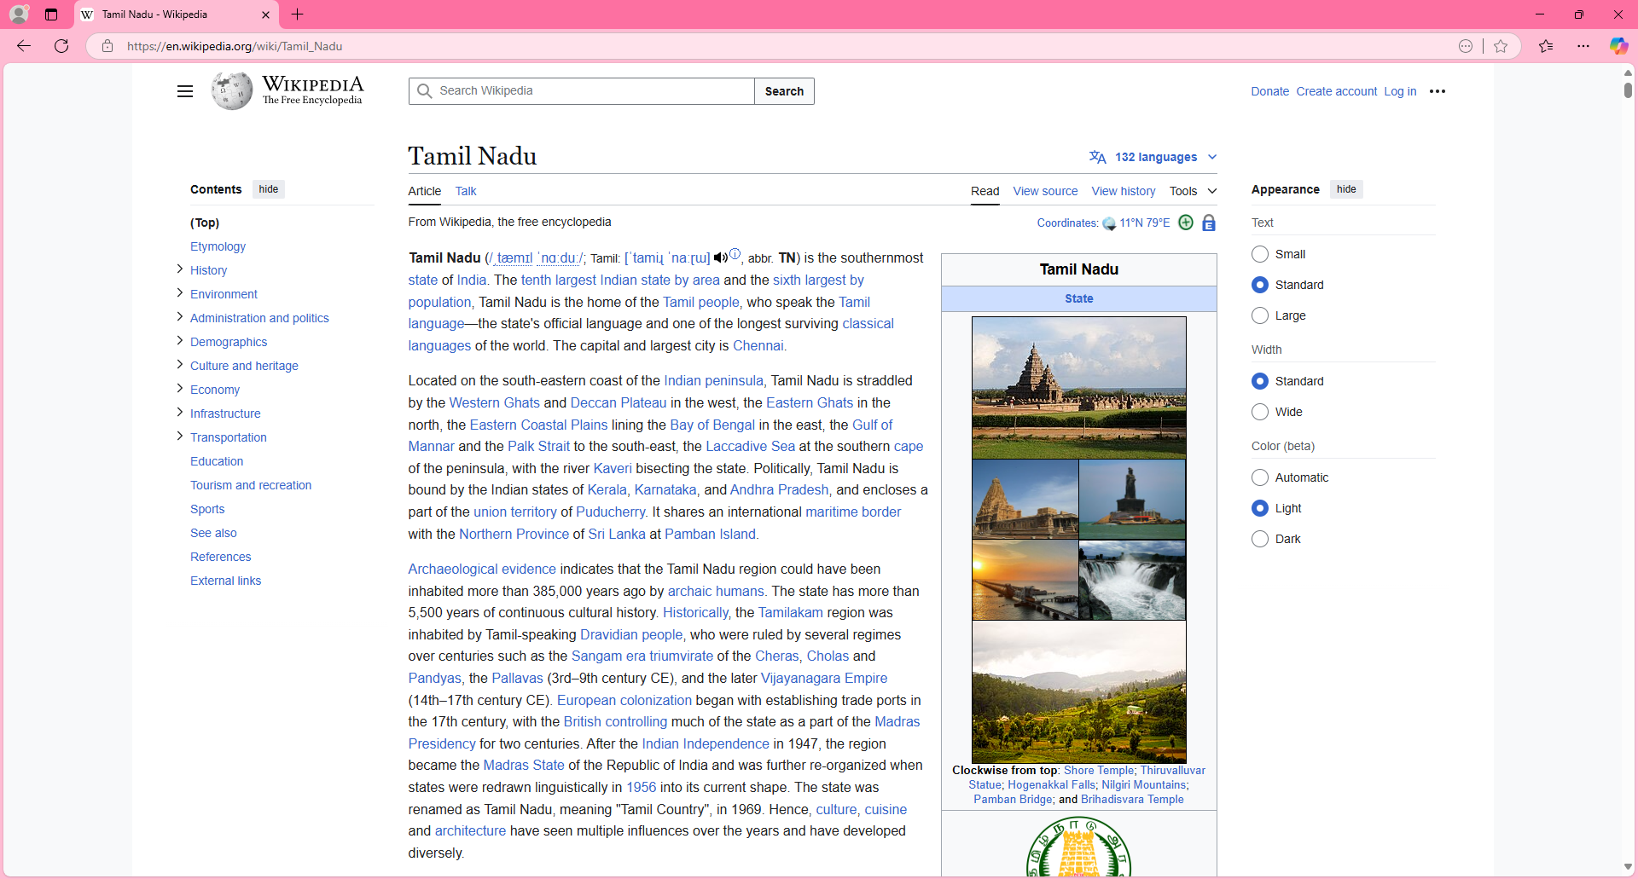

**RESULT:**

Validating the username and age is is done successfully and displayed in the browser.